OUTPUT SCREENSHOTS:

REGISTERATION PAGE:

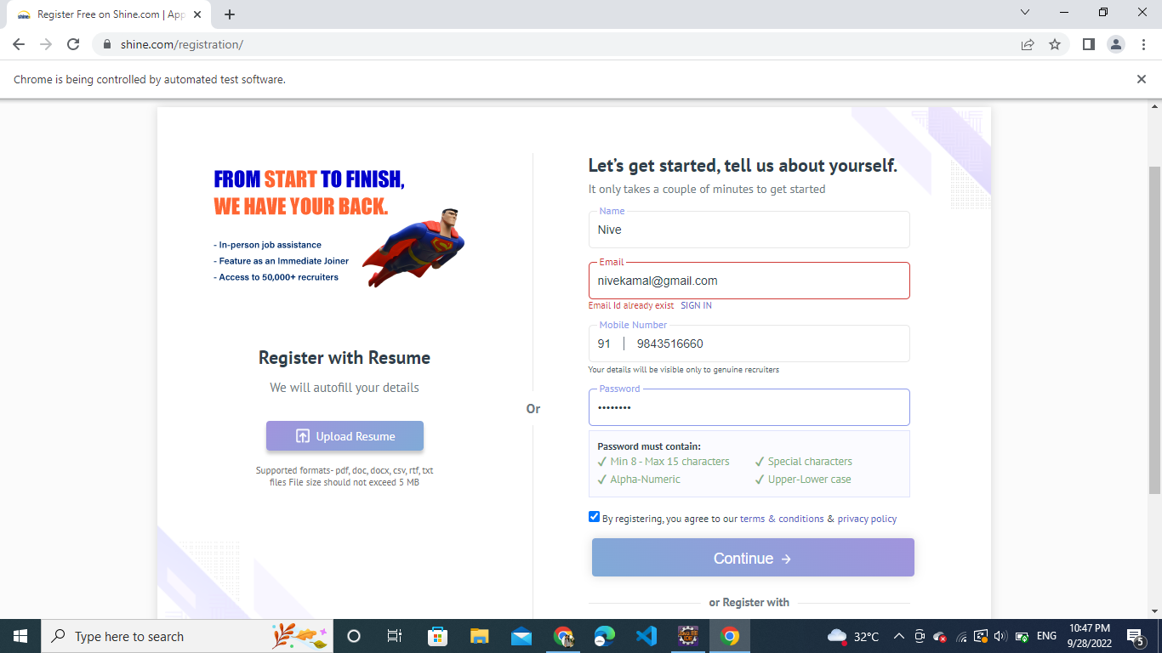

LOGIN PAGIN:



